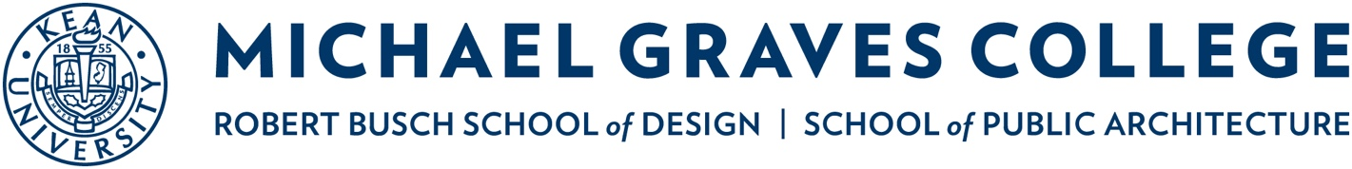

KEAN UNIVERSITY

PARENTAL CONSENT

I, ____________________________________, give permission for my child, ______________________________ to participate in the Michael Graves College of Architecture & Design “Design for Social Good” Graphic Design Poster Competition at Kean University (hereinafter referred to as the “Competition”). I recognize and understand that my child is participating in the Competition voluntarily and that such participation in the Competition is optional. In consideration for the acceptance of my child’s poster entry, I hereby grant Kean University permission to publicly display my child’s poster entry, if selected, and to reproduce, distribute and/or use my child’s poster in any medium (e.g. print publications, video tapes, CD-ROM, Internet/WWW) for any non-commercial purpose as determined by Kean University. I consent to the use of my child’s photograph, name and school in connection with their poster entry. I understand and agree that if my child is the first place winner of the Competition, Kean University will honor the scholarship upon my child’s enrollment in the Michael Graves College for Fall 2021 or Fall 2022.

I hereby do forever release from fault and hold harmless Kean University, the State of New Jersey, and any trustee, director, officer, agent, employee, member, volunteer or any other representative of Kean University, the State of New Jersey or any of their respective successors or assigns (collectively, “Kean”) against loss (including court costs and reasonable attorneys' fees) from any and all claims, demands, rights, or causes of action of any kind or nature that may result from or in connection with my child’s participation in the Competition, including any third party claims for copyright infringement in connection with Kean’s use of my child’s poster entry.

Name of Parent or Guardian (Print): ________________________________________________

Signature:_____________________________________________ Date:___________________

